TrueBand Internet Services

Subscriber AdminTool
User Guide

August 2004

1. Introduction to this Guide 3
2. Login to the AdminTool 3
Return to login screen if inactive for two (2) hours. 4
Logout of the AdminTool 5
3. Change Your Password 5
4. Download Pop-up Stopper 7
Install the Pop-Up Stopper 8
Register Pop-Up Stopper 8
Pop-Up Stopper tool bar appears 10
5. Set Auto-Reply 10
6. Set FrontPage Access 11
7. Forward e-mail to other accounts 11
8. Delete Accumulated E-Mail 12
9. Review Usage and Settings 13
10. Print or e-mail account information 14

Introduction To This Guide
You don’t have to carve time out of your busy schedule to call the ISP business office to change your password or to check your account information.
Save time and gain control over important account settings with the AdminTool! With this easy to use Web tool, you can make the changes you need to your account, set Spam filtering, and have your changes take effect immediately—no waiting.
Follow the quick and easy instructions in this handy reference to get started.
This manual provides step-by-step instructions to perform these tasks:

- Change password (section 3)
- Download popup-blocking software
- Set Auto-reply (section 6)
- Set FrontPage access
(section 7)
- Forward e-mail to other accounts (section 8)
- Delete unopened e-mail from your account (section 9)
- Review account information (section 10)

To set Spam Filtering, please see the guide Spam Filtering from Your ISP.

Login To The Admintool
- Type admintool.yourisp.yourdomain into the address bar of your Web browser and press the Enter key on your keyboard. The illustration below uses the address for admintool.trueband.net (Figure 1).
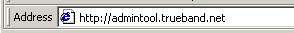
Figure 1.
- Enter your User Name and Password in the appropriate fields on the login page and click the Log In button (Figure 2). Your User Name is the same as your Login Id.
Note: User Name and Password are case-sensitive. Please make sure that you enter the User Name and Password exactly as when the account was created (or last modified).
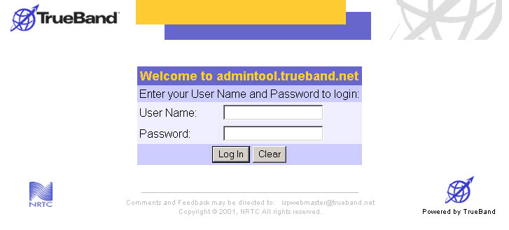
Figure 2.
Note: If you have lost your Password, please call your ISP business office during normal business hours.

After successful login, the AdminTool homepage appears (Figure 3).
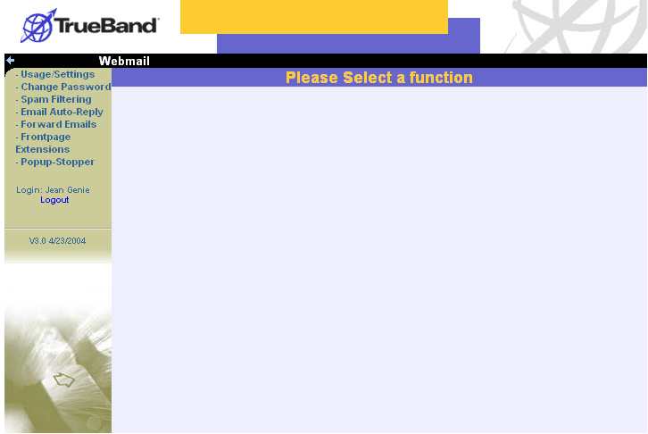
Figure 3
Menu items are listed on the left of the screen (Figure 4):
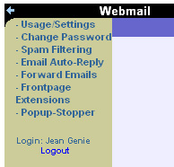
Figure 4.

Return to login screen if inactive for two (2) hours.
To provide added security, the AdminTool returns to the login page if you have not worked in the tool for two hours. When you try to work in the AdminTool after having left it for two hours, you will receive the message that the session “has timed out” (Figure 3). To work in the application further, the user must login again.
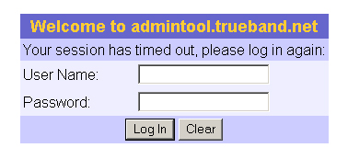
Figure 5

Logout of the AdminTool
The AdminTool provides two ways to logoff: leave the system or return to the Login prompt.
To leave the AdminTool, select the “X” in the upper-right of your Web browser.
To return to the Login prompt (Figure 2), select Logout from the menu on the left of the screen (Figure 5).

Change Your Password
Select Change Password from the menu to access the Change Password screen (Figure 6).
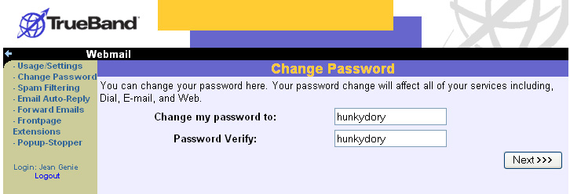
Figure 6
Your current password appears in the field. To change your password:
- Enter a new password into the Change my password to field
- Enter the same new password in the Password Verify field
- Click the Next button

At the Change Settings – Verify screen (Figure 6), make sure the password is correct.
Note: After changing your password, you will be prompted to login using the new password before you can perform other tasks in the AdminTool.
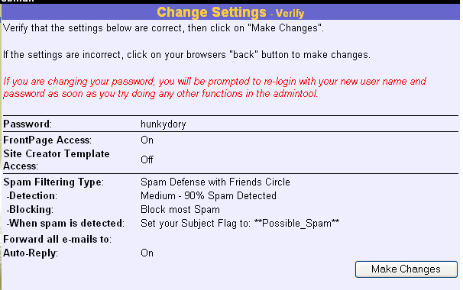
Figure 7
If you need to edit your changes, select Change Password from the menu on the left.
To accept your new password, click the Make Changes button. The Change Settings – Create screen will appear (Figure 7).
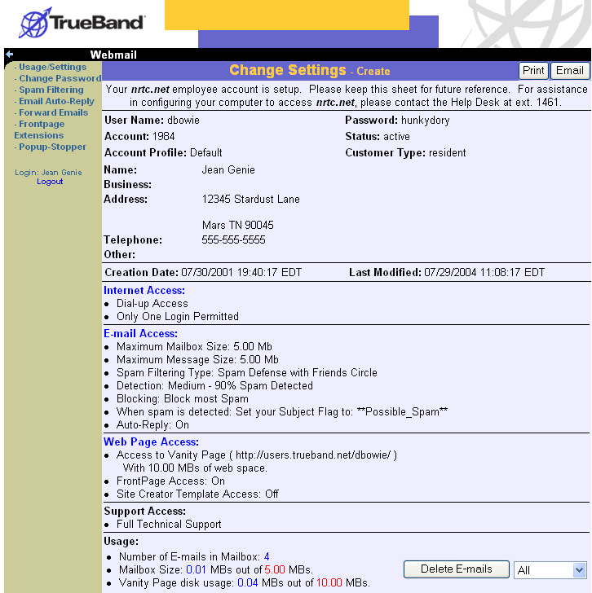
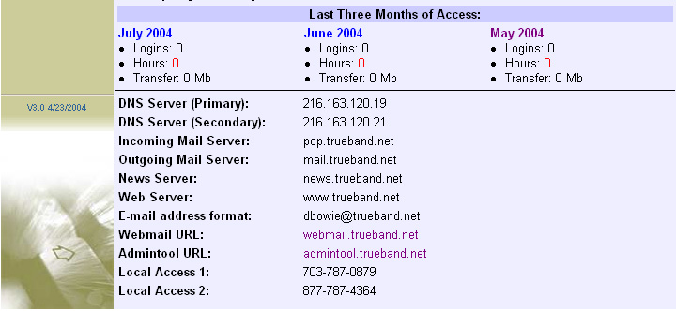
Figure 8

Download Pop-up Stopper
We know how distracting it can be to have annoying Web advertisements pop up while you are surfing the Internet.
As your ISP, we want to help you have a quality Internet experience by reducing annoyances like pop-up and pop-under advertisements.
Our robust pop-up stopping software provides advanced ad-blocking technology:
  - Block pop-up and pop-under ads, including X10 and Casino windows
  - Allow pop-up windows from sites YOU choose
  - Preserve bandwidth by stopping pop-ups before they load!
  - View the number of pop-ups blocked, and from which site!
  - Play a sound when a pop-up is blocked
Take advantage of this great service by downloading the software and follow the simple directions to install it on your computer.
To download the pop-up stopper, select Pop-up Stopper from the menu of the left of the screen.
Read the directions on the Pop-up Stopper screen before clicking the Download button to begin the download process (Figure 10).
Note: The Pop-up Stopper is available only for
Windows Internet Explorer.
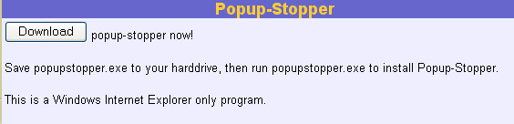
Figure 9
Depending on the operating system you have installed on your computer, you may receive a message like the one below (Figure 11). Click the option to Save the program to your computer.
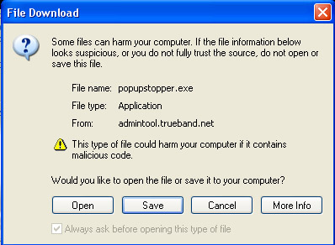
Figure 10
Logout of the AdminTool and close all programs, including your Internet connection, to install the program.

Install the Pop-Up Stopper
When download is complete, close all other applications and double-click the Pop-Up Stopper setup icon, or, select Run from the Start menu, browse to the desktop, and select popupstopper.
Follow installation instructions (Figure 12).
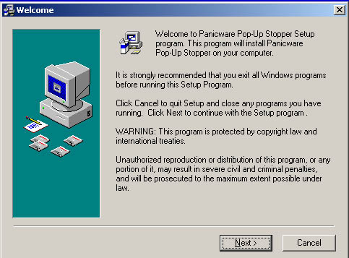
Figure 11

Register Pop-Up Stopper
When installation is complete, the Pop-Up Stopper Setup Wizard opens (Figure 13). Follow the setup wizard instructions
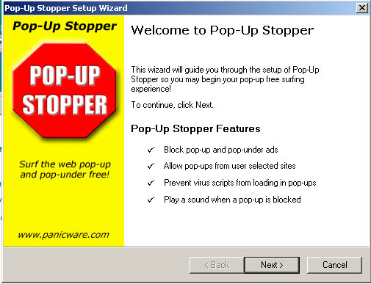
Figure 12
Provide your e-mail address to receive the activation code (Figure 13).
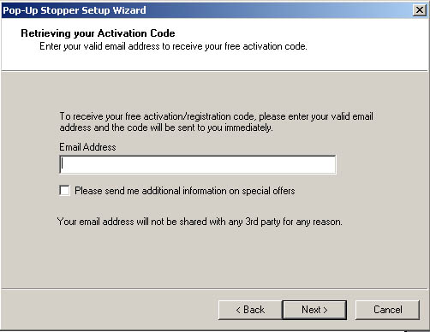
Figure 13
After providing your e-mail address, the registration code will be e-mailed to you.
Enter the registration code in the fields provided and click Next to complete setup.
When setup is complete, a Web browser automatically opens to a “Welcome to Pop-Up Stopper” Web page. This page answers questions about using Pop-Up Stopper (Figure 15).

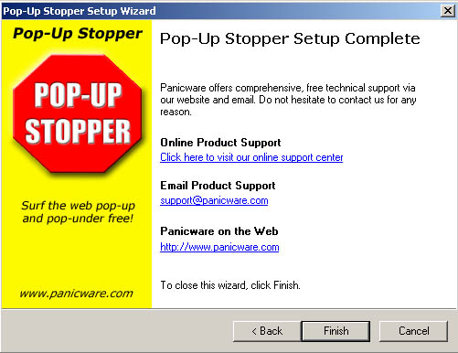
Figure 14

Pop-Up Stopper tool bar appears
When installation is complete, the Pop-up Stopper tool bar should appear on your browser (Figure 16).
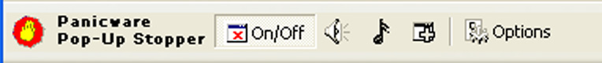
Figure 15
If the tool bar does not appear, place your mouse in a gray area of the Web browser and right click to reveal the selected tool bars. Make sure the tool bar for “Panicware Pop-Up Stopper” is selected.

Set Auto-Reply
Respond to e-mail automatically, even when you’re not online! The Auto-reply feature is especially useful when you are on vacation or unable to access e-mail for a long period of time.
When E-mail Auto-Reply is on, your auto-reply message will be sent automatically to anyone who e-mails you.
To insert an Auto-reply message,
- Log on to the AdminTool
- Select E-mail Auto-Reply from the menu on the left side of the screen
- Default text is provided in the field (Figure 17). If you want to change it, enter your message in the field.
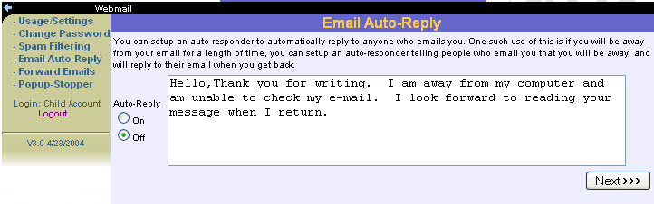
Figure 16
- To turn Auto-reply on, select the “On” radial button
- Click the Next button
- Verify that Auto-reply is on by reviewing the settings on the Change Settings - Verify screen (Figure 18)
- If settings are correct, click the Make Changes button
- If settings are incorrect, click E-mail Auto-Reply on the menu to make the desired changes.
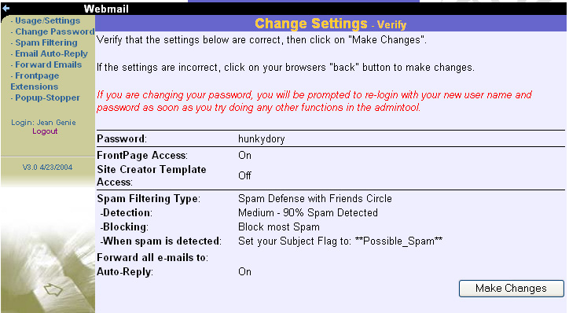
Figure 17

Set FrontPage Access
Your ISP supports Microsoft FrontPage (98 and 2000) for making personal Web pages. To set FrontPage Access, select FrontPage Extensions from the menu on the left of the screen to access FrontPage Extensions screen (Figure 19).
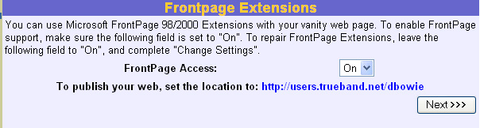
Figure 18.
Activating FrontPage Access will use approximately 3.5 megabytes (MBs) of your Web page space allotment.
To activate FrontPage access,
- Select “On” from the dropdown menu
- Click the Next button
- Verify settings by reviewing the Change Settings – Create screen (Figure 7).

Forward E-Mail To Other Accounts
You may decide to forward the e-mail you receive from this account to another account so that all of your e-mail comes to one centralized location. To forward e-mail from this account to other e-mail accounts, select Forward E-mails from the menu on the left of the screen to access the Forward E-mails screen (Figure 19).
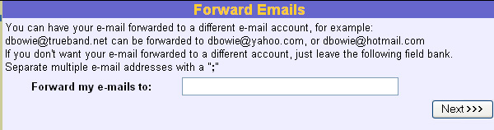
Figure 19
To forward your e-mail to multiple accounts; separate each e-mail addresses with a semicolon (;).
To forward your e-mail to other accounts:
- Enter the e-mail addresses to which you would like your e-mail forwarded in the field.
- Click the Next button
- Verify your settings by reviewing the Change Settings- Create screen (Figure 18)
- If settings are correct, click the Make Changes button
- If settings are incorrect, click Forward E-mails on the menu to make the desired changes.

Delete Accumulated E-Mail
From the AdminTool, you can delete e-mail that has accumulated in your e-mail in-box. This powerful feature can save you time—if you know that you don’t want to save any of the e-mail that has piled up in your account.
Be careful—there is no retrieval function.
To delete accumulated e-mail,
- Select the Usage/Settings menu item from the left of the screen
- From the Usage/Settings screen, scroll to the Usage section and select the amount of e-mail you would like to delete from the dropdown menu (Figure 20).
- Click the Delete E-mails button
Note: Once you delete e-mail, you cannot recover it!
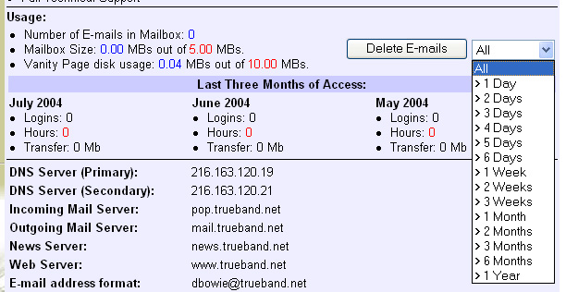
Figure 20
Before accepting the deletion, check on the message prompt whether the amount of e-mail to delete displays in the prompt. In the example below, the amount of accumulated e-mail the user has selected to delete is “All.” To accept and delete the e-mail, click OK. To cancel the deletion and keep the e-mail, click Cancel.
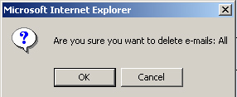
Figure 21.
After processing the deletion request, the AdminTool returns the user to the Usage/Settings screen.

Review Usage and Settings
On occasion, it is a good idea to review your account information, usage, and settings to make certain that all information is current.
To do so, select the Usage/Settings menu option from the left of the screen (Figure 4).
Review the following areas of the Usages/Settings screen and follow the instructions provided if changes are required:
User Name and Password | If you would like to change your password, please refer to the Change Your Password section of this guide.
Address | If the recorded address is different from you current one, please call the ISP business office to update your account.
Telephone | If the recorded telephone number is different from you current one, please call the ISP business office to update your account.
E-mail Access | To increase the size of your e-mail box, please call the ISP business office. Charges may apply.  To set Spam filtering, refer to the guide Spam Filtering from Your ISP.  To set auto-reply, please refer to Set Auto-Reply in this guide.
Web page Access | To increase your Web space, please call the ISP business office. Charges may apply.  To use FrontPage to create your personal Web page, turn FrontPage Access On. To do so, refer to Set FrontPage Access in this guide.  To use Site Creator templates to create your Web page, call the ISP business office. Charges may apply.
Usage | Check mailbox size. If you are near capacity for e-mail space, you may need to delete accumulated e-mail. See Delete Accumulated E-mail in this guide.  To increase your Web space, please call the ISP business office. Charges may apply.  Check usage for the last three months. This report provides a summary of your online activity, including the number of times you have logged on, hours spent online, and amount of material transferred within the month.

Print or e-mail account information
Keep a copy of your account information for your records:
- Print: Click the Print button in the upper right of the screen. Follow the directions for printing to your printer.
- E-mail: Click the E-mail button in the upper right of the screen to access the View User – User Data Listing screen (Figure 8). Enter the address to which you want to e-mail your account information. Enter any comments in the Comments field. To send, click the E-mail Subscriber Data button.
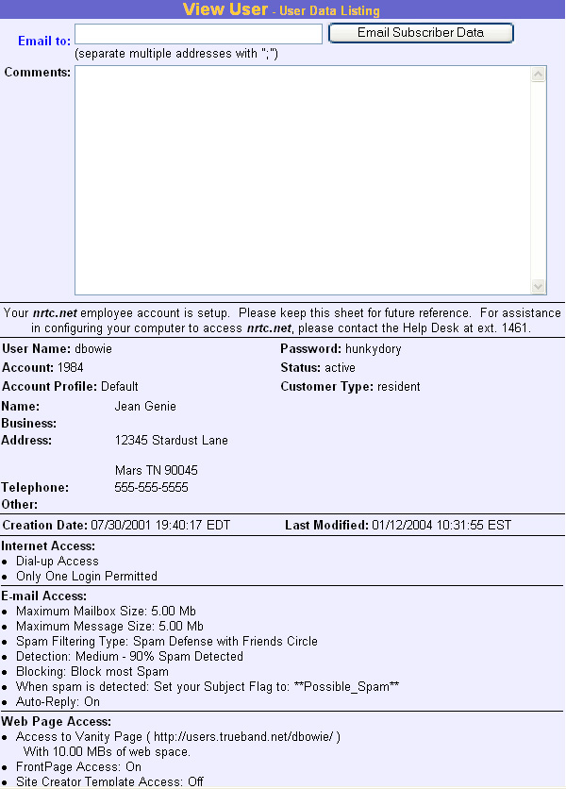
Figure 22

