Installing Internet Explorer 6

Welcome!
Soon you will be surfing with the latest version of Internet Explorer!
If you have problems with installation, please call our technical support specialists at [insert number].

Insert CD in disc drive
- Upon inserting the CD in the disc drive of your computer, the menu opens automatically (Figure 1).
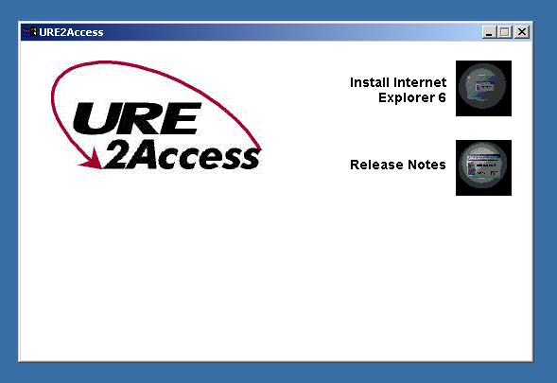
Figure 1
Note: If menu does not open, from the Start menu, point to Run, and click Browse. Then select cdsetup.
  - Double click the Install Internet Explorer 6 menu option to begin installation.

Accept license agreement
  - Read the license agreement (Figure 2).
  - Select I accept the agreement.
  - Click Next.
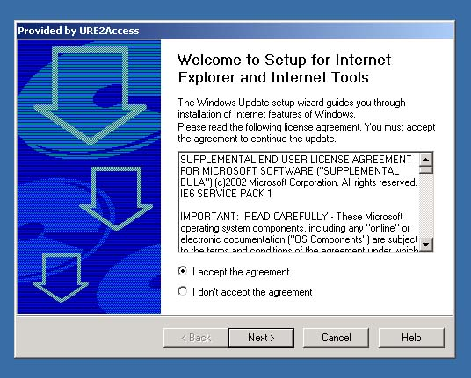
Figure 2

Install Update
- Click Next to begin the update process (Figure 3).

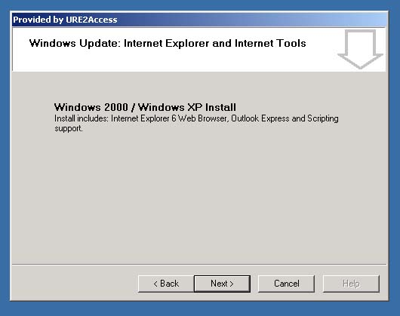
Figure 3
- Please wait while the update is in progress (Figure 4).
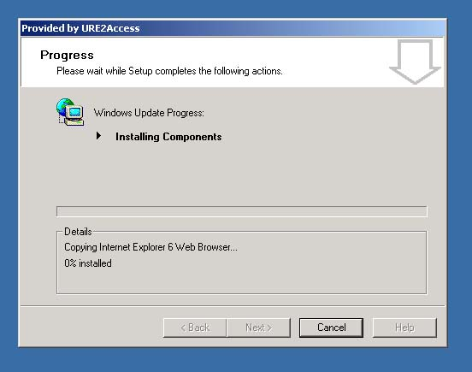
Figure 4

Restart your computer
- Save work and close applications.
- Restart your computer (Figure 5).
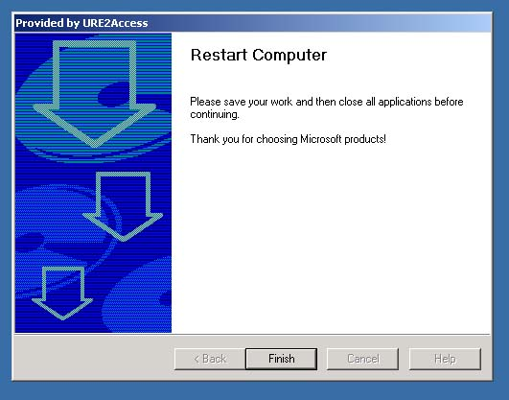
Figure 5

Installation complete
- Upon restarting your computer, the following message displays (Figure 6), indicating successful installation. You are now ready to surf using Internet Explorer 6!
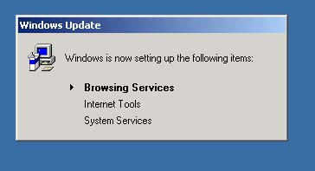
Figure 6

